Hardware And Components

Assignment Day-2
Task-1: Draw a labeled diagram of an ATX motherboard and mark at least 8 different slots and ports (such as RAM slots, PCIe slots, SATA ports, USB headers, CPU socket, power connector, etc.).
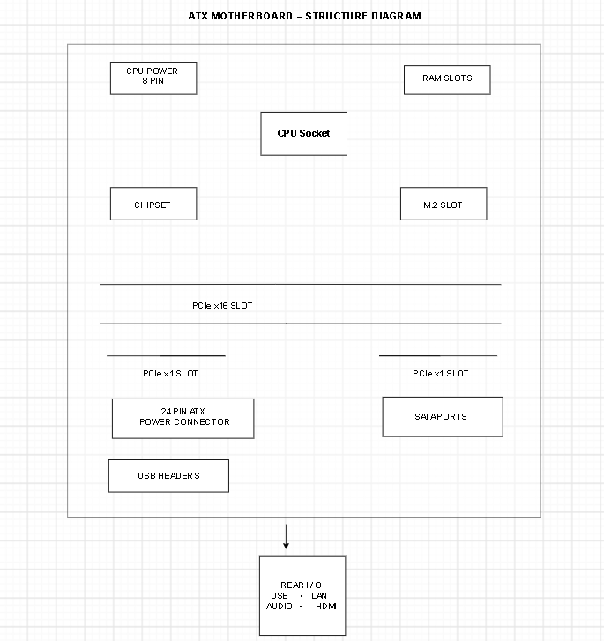

ATX Motherboard – Labeled Diagram
1. CPU Socket:
Holds the CPU (processor) and connects it to the motherboard.
2. RAM Slots (DIMM):
Used to install RAM, which temporarily stores data and programs while the computer is running.
3. PCIe x16 Slot:
Used mainly for installing a graphics card (GPU).
4. PCIe x1 Slots:
Used for expansion cards such as Wi-Fi, sound, or network cards.
5. SATA Ports:
Used to connect storage devices such as HDDs and SATA SSDs.
6. 24-pin ATX Power Connector:
Supplies the main power from the power supply unit (PSU) to the motherboard.
7. 8-pin CPU Power Connector:
Provides power specifically to the CPU.
8. USB Headers:
Used to connect the motherboard to the computer case's front USB ports.
9. M.2 Slot:
Used to install compact M.2 SSDs for fast storage.
10. Rear I/O Ports:
Provide external connections such as USB, Ethernet/LAN, audio, HDMI/DisplayPort, etc.
11. Chipset:
Controls communication between the CPU and various components connected to the motherboard.
12. CMOS Battery:
Maintains BIOS/UEFI settings and the system clock when the computer is switched off.
Task-2: Research and list 3 popular CPU socket types (for example: LGA1151, AM4, LGA1200) and name one compatible CPU model for each.

3 Popular CPU Socket Types
A CPU socket is the slot on a motherboard where the processor is installed. Different processors are designed for specific socket types, so the CPU and motherboard must have a compatible socket.
- LGA1151 – This socket was commonly used by several Intel processors. One compatible CPU is the Intel Core i7-9700K, which is an 8-core processor designed for LGA1151 motherboards.
- AM4 – AM4 is a popular socket used by AMD Ryzen processors. One example is the AMD Ryzen 5 3600, a 6-core processor commonly used in gaming and general-purpose PCs.
- LGA1200 – This socket was introduced for Intel's 10th and 11th generation desktop processors. One compatible CPU is the Intel Core i5-10400, which is a 6-core processor suitable for everyday use and gaming.
Task-3: Explain in your own words the primary functions of the CPU and the chipset on a motherboard, and describe how they work together when you open a music app like Spotify.
CPU (Central Processing Unit)
The CPU is the main processing unit of a computer. It executes instructions, performs calculations, and manages tasks requested by software and users. The CPU is often called the "brain" of the computer because it controls most operations.
Chipset
The chipset is a group of electronic components on the motherboard that manages communication between the CPU, RAM, storage devices, USB ports, and other hardware. It acts as a traffic controller, ensuring data moves correctly between components.
How They Work Together When Opening Spotify
When I open Spotify, the CPU processes the command to launch the application and loads the necessary program instructions. The chipset helps transfer data between the SSD, RAM, audio hardware, and CPU. The CPU executes the software while the chipset manages communication with storage, speakers, and network devices, allowing Spotify to load and play music smoothly.
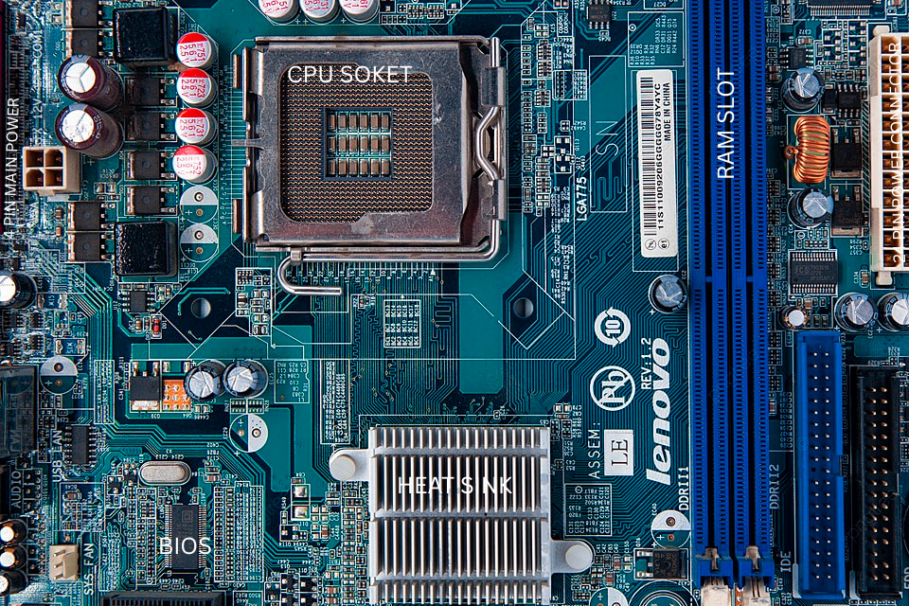
Task-4: Find a clear photo of a real motherboard (from the internet or your own device), and identify at least 5 different ports or slots by circling them and labeling each one.

